Database

SQL Database SQL PLSQL

SQL –4GL ---- what to do it ----- unified language

PLSQL----- how to do? if , loops, functions, procedures,tigger

* Oracle---------- Oracle -------- JAVA
* mysql---------- JAVA
* prostgresSQL
* SQL Server ------- Microsoft-------.NET

NOSQL

* MongoDB
* Caasandra
* Couchbase

GraphDB

* Neo4j

Memory database

* MemDB
* VoltDB

|  |  |
| --- | --- |
| SQL | NOSQL |
| Structured | Unstructured |
| Table | Collection |
| Secure---- financial application | Less secure-----social media |
| Transaction control | No transaction control |

MySQL

Table

every row is unique

primary key---- minimal subset of the columns, that identifies the row uniquely

Empid ------ primary key

candidate key----passportno, adharcard, empid

Empid+ename 1111Kishori ----- super keys

Empid+desg+name 1111ManagerKishori

|  |  |  |  |  |  |
| --- | --- | --- | --- | --- | --- |
| Empid | Ename | Passport number | Desg | Adhar card | sal |
| 1111 | Kishori | 12345 | Manager | 23456 | 34567 |
| 2222 | Kishori | 33333 | Manager | 555555 | 34567 |
| 3333 | Rajan | 444444 | Game designer | 666666 | 444444 |
| 4444 | Revati | 555555 | UX Designer | 777777 | 454545 |

super keys---- any combination of columns which uniquely identify the row

primary --- room no

|  |  |  |  |
| --- | --- | --- | --- |
| Room no | Name | Location | size |
| 1 | Lotus | 3rd floor | 14X14 |
| 2 | Jasmin | 1 st floor | 12X12 |
| 3 | Jasmin | 3rd floor | 12X12 |

Room booking

one room will be booked by one customer in the particular period

primary key roomno+from dt+to dt -------- composite key

super key

roomno+from dt+to dt+cname

roomno+from dt+to dt+cname

|  |  |  |  |  |  |  |
| --- | --- | --- | --- | --- | --- | --- |
| Roomno | Custnum | Cname | From dt | To dt | charges |  |
| 1 | 10 | Kishori | 1 june | 10 june | 3000 |  |
| 2 | 10 | Kishori | 1 june | 10 june | 3000 |  |
| 1 | 20 | Rajan | 15 june | 30 jun | 5000 |  |
| 1 | 10 | Kishori | 1 july | 15 july | 6000 |  |

student information

primary key -studid+module

super keys studid+module studid+module+coursed studid+module+marks

|  |  |  |  |
| --- | --- | --- | --- |
| Studid | Coursid | Marks | module |
| 121 | 1 | 99 | JAVA |
| 121 | 1 | 99 | DBMS |
|  |  |  |  |

primary key ----- minimal subset that identifies the row uniquely

super key ----- any combination of columns that uniquely identify the row

candidate key---- any minimal subset which

Employee

|  |  |  |  |
| --- | --- | --- | --- |
| Empno | Ename | Address | deptno |
| 1 | Kishori | Baner | 10 |
| 2 | Rajan | Aundh | 20 |
| 3 | Revati | Baner | 10 |
| 4 | Ashwin | Pashan | 30 |

Dept

|  |  |  |
| --- | --- | --- |
| Deptno | Dname | location |
| 10 | Hr | Pune |
| 20 | Sales | Mumbai |
| 30 | Purchase | chennai |

foreign key----- if the data of any column is validated with the primary key of other table or same table then it is called as primary key

integrity ------ referential integrity

employee

(employeenum,ename,mgr number)

primary key – emp num

foreign key--- mgr num

|  |  |  |
| --- | --- | --- |
| Emp Num | Name | Mgr num |
| 1 | Kishori | 5 |
| 3 | Rajan | 1 |
| 4 | Revati | 11 |
| 5 | Anil |  |

flight booking table

primary key---flightno,seatno.date of booking

foreign key ----- flightnumber

|  |  |  |  |  |
| --- | --- | --- | --- | --- |
| Flightno | Seatno | Date of booking | charges |  |
| 1 | 12 | 1 jun | 5000 |  |

fligh table

primary key- flight num

|  |  |  |  |
| --- | --- | --- | --- |
| Flightno | Flightname | Start | end |
| 1 | aaa | Pune | GOA |
|  |  |  |  |

Date : 3.06.2021

problems are : redundancy

cannot guarantee correctness of data

|  |  |  |  |  |  |  |  |
| --- | --- | --- | --- | --- | --- | --- | --- |
| a/c no | Name | Address | Mob no | balance | Type of account |  |  |
| 1 | Kishori | Baner | 2222 | 555555 | saving |  |  |
| 2 | Rushikesh | Pashan | 4444 | 666666 | saving |  |  |
| 3 | Kishori | Baner | 2222 | 4444444 | demat |  |  |
| 4 | Kishori | Aundh | 2222 | 4444444 | current |  |  |

divide into multiple tables ----- to rduce redendancy

|  |  |  |  |  |  |
| --- | --- | --- | --- | --- | --- |
| Cust id | Name | Adress | mobno |  |  |
| 1 | Kishori | Aundh | 2222 |  |  |
| 2 | Rushikesh | Pashan | 4444 |  |  |

|  |  |  |  |
| --- | --- | --- | --- |
| a/c no | Balance | type | custid |
| 1 | 555555 | saving | 1 |
| 3 | 4444444 | Demat | 1 |
| 2 | 666666 | saving | 2 |
| 4 | 4444444 | current | 1 |

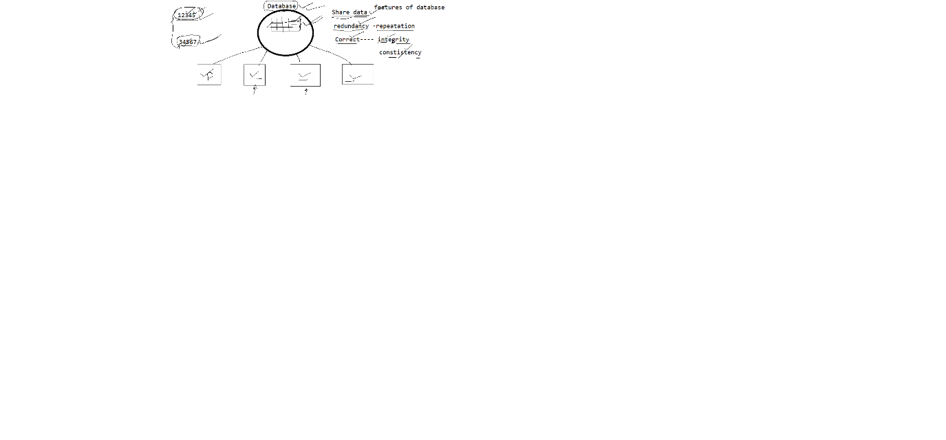

SQL- structured Query Language

|  |  |  |
| --- | --- | --- |
| Types |  |  |
| DQL | Data Query Langugae | Select |
| DML | Data manipulation language | Insert, delete, update |
| DDL | Data Definition language | Create,alter,drop |
| DCL | Data control language | Grant ,revoke |
| TCL | Transaction control language | Commit  Rollback  savepoint |

* To retrieve data from emp table

select * from emp;

* To retrieve data from dept

select * from dept;

* to retrieve all the information of emp with sal >1500

select *

from emp

where sal>1500;

* to retrieve information of emp with sal >=1500 and <= 3000

select *

from emp

where sal >=1500 and sal <=3000;

between … and … operator is used to change the range of data so

1500 and 3000 are inclusive

select *

from emp

where sal between 1500 and 3000;

* to find all employees who are working as analyst

select *

-> from emp

-> where job >'ANALYST';

* to find all emp whose manager is 7902

> select *

-> from emp

-> where mgr=7902;

* to display all emp whose name is SMITH

select *

from emp

where ename=’SMITH’;

to find employees who joined in augst

all strings and date has tobe enclosed in single quote. and default format of data is

yyyy-mm-dd

select *

-> from emp

-> where hiredate='1981-12-03';

* to display all employees whose name is either SMITH or ALLEN

select *

from emp

where ename='SMITH' or ename='ALLEN'

select *

from emp

where ename in (‘SMITH’,’ALLEN’);

* to display all employees with sal >=2500 and <=3400

select *

from emp

where sal between 2500 and 3400;

* to display all employees with sal =1500 or 2500 or 3500

select *

from emp

where sal =1500 or sal=2500 or sal=3500;

***************

select *

from emp

where sal in (1500,2500,3500);

* to find all users who earn no commission

select *

-> from emp

-> where comm is null;

* to find all users who earn commission

select *

-> from emp

-> where comm is not null;

* to display all employees whose name starts with A

in like operator

%----- 0 or more characters

_ ----------- exactly one character

select *

from emp

where ename like 'A%';

* to find all employees with name ending with R

select *

from emp

where ename like ‘%R’

* display all employee with name starts with a and ends with n

select *

from emp

where ename like ‘A%N’;

* display all employee with name starts with M and L at third position and ends with R

select *

from emp

where ename like ’M_L%R’;

* display all employee with name starts with S and T at second last position

select *

from emp

where ename like ‘S%T_’;

* display all employee with name starts with either S or ends with N or starts with M

select *

from emp

where ename like ‘S%’ or ename like ’%N’ or ename like ’M%’;

REGEXP operator

To use with REGEXP

Occurance symbol

* ----- o or more occurances

+ ----- 1 or more occurances

? ----- o or 1 occurance

{m} ---- exactly m occurances

{m,n} --- minimum m occurances and maximum n occurances

special symbols

^ --- start position

$ ---- end position

[A-Za-Z] ---all alphabets

[aeiou] ---- any one wovel

[^abc] ---- anything other than abc

. ---- matches with any one character

| ---- to combine multiple patterns

^A.*N$

AN

ALLEN

'N$'

'.M.*'

SMITH

starts with A or starts with S or ends with N

^A|^S|N$

select *

from emp

where ename REGEXP '^A|^S|N$'

to find all useres with name starts with A and L at 3rd position

or starts with M and ends with R

select *

from emp

where emp REGEXP '^A.L|^M.*R$'

select *

-> from emp

-> where ename like 'A_L%' or ename like 'M%R';

display all employees which has vowel at 2nd position

select *

from emp

where ename REGEXP ‘^.[aeiou]’

to display empno and name of all employees with salary > 1500

select empno,ename

from emp

where sal > 1500;

* names starts with mi or starts with al

select * from emp

where ename like ‘MI%’ or ename like ‘AL%’

select *

from emp

where ename REGEXP ‘^MI|^AL’;

* name ends com or co

select * from emp

where ename like ‘com$|co$’

select * from emp

where ename REGEXP ‘com?$’

select *

from emp

where ename like ‘%com’ or ename like ‘%co’

Number functions

1. abs ----converts number in to + ve number
2. round(number,precision) ---- will round the number up to specified precision
3. truncate(number,precision) --- will truncate number to specified precision
4. ceil (number) ------ always give next complete number
5. floor(number) -----always give previous complete number
6. power(numer,n1) ----- number raise to n1
7. cos(number) ---- cosine of number
8. exp(3) ---- e raise 3
9. greatest(23,22,33,11,44,55,)
10. Least(23,22,33,11,44,55,)

character functions

1. lower ---- convert into lowercase
2. lcase ------ convert into lower case
3. upper --- convert into uppercase
4. ucase--- convert into uppercase
5. concat(str1,str2,…..) --- concate all the strings
6. lpad(str,length,ch) ------ it will add ch on the left hand side of str to make total length = geven length
7. rpad(str,length,ch) ------ it will add ch on the left hand side of str to make total length = geven length
8. left(str,3) ------ it will retrieve leftmost 3 character
9. right(str,4) ------ it will display rightmost 4 characters
10. substr(str,pos,n) ----will retrieve n characters from the given position
11. substring((str,pos,n) ----will retrieve n characters from the given position
12. replace(str,old str,new str) ---- it will replace old str from given str with new str
13. reverse(str) ----------- display string in reverse order
14. trim(str) ------ removes leading and trailing spaces
15. rtrim(str) ------------ removes spaces from right side
16. ltrim(str) ------------ removes spaces from left side

date related functions

1. year(date) ----- retrieve year
2. month(hiredate) ---- retrieves month
3. day(hiredate) ---- retrieve the date

---list all employees who joined in 1981

select empno,name,hiredate

from emp

where year(hiredate)=1981;

------ to display all employees number ,name,email (name + “3 characters of job”+”@mycompany.com”)

for all employees who joined in 1981

select empno,ename,concat(ename,substr(job,1,3),’ @mycompany.com’) email

from emp

where year(hiredate)=1981;

------ to display all employees who joined in aug 1982

select empno,ename,concat(ename,substr(job,1,3),’@mycompany.com’)

from emp

where month(hiredate)=12 and year(hiredate)=1982;